|  |
| --- |
| 2_color-small |
| Routing Guide &  Supplier Compliance Instructions |
|  |
|  |
|  |
|  |



Dear Supplier:

Winn-Dixie is committed to providing its customers with high quality service. To achieve this, Winn-Dixie continuously strives to improve the effectiveness and efficiency of its operations.

Winn-Dixie’s Logistics Department has implemented new routing procedures and revised its freight handling instructions. Our new and revised instructions appear in this document. The instructions cover routing, scheduling, documentation, and packaging of merchandise for shipment to Winn-Dixie distribution centers and stores. For your convenience, these instructions are also posted on Winn-Dixie Supplier Website at;

*www.winn-dixie.com*.

We believe that you will find our requirements standard industry protocol. However, if you have any questions or require additional information about any of our procedures, please contact the individuals listed below for assistance:

Routing: Darryl Hill 904-370-6281 [darrylhill@Winn-Dixie.com](mailto:darrylhill@Winn-Dixie.com)

Compliance: Gary Regina 904-370-6351 [garyregina@Winn-Dixie.com](mailto:garyregina@winn-dixie.com)

Winn-Dixie and its suppliers will benefit from these procedures as they are designed to enhance the overall efficiency of merchandise handling, control cost, and improve customer service.

Please forward these instructions to the responsible individuals in your distribution and logistics organizations.

**TABLE OF CONTENTS**

General Instructions ……………………………………………………………….. Page 4

Distribution Center Addresses …………………………………………………….. Page 5

Distribution Center Receiving Hours …………………………………………….... Page 7

In-Bound Pallet Program ………………………………………………………….. Page 8

Pallet Standards ……………………………………………………………………. Page 10

Case Integrity Standard ……………………………………………………………. Page 13

In-Bound Receiving ……………………………………………………………….. Page 14

Temperature Specifications ………………………………………………………... Page 17

Guidelines for Case Markings and Packaging Requirements ……………………... Page 18

Minimum Freshness Guidelines …………………………………………………… Page 22

In-Bound LTL Program ………………………………………………………….… Page 23

3rd Party Unloading Charge Rates …………………………………………………. Page 24

Product Recall/Removal Processing Fees ……………………………………………….. Page 25

**I. General Instructions**

1. This Guide supersedes all previous routing guides and freight handling instructions issued by Winn-Dixie.
2. This Guide contains detailed instructions for the routing, scheduling, documentation, and packaging of merchandise for shipment to Winn-Dixie distribution centers and stores.
3. The instructions apply to all purchase orders issued by Winn-Dixie and are incorporated by reference into the terms and conditions of all Winn-Dixie purchase orders.
4. Noncompliance with the Winn-Dixie routing and freight handling requirements will result in a chargeback of all excess expenses incurred plus an administrative fee.
5. Each supplier is responsible to forward this Guide to its Logistics Department and other affected individuals responsible for the delivery of product to Winn-Dixie distribution centers and stores.

**DISTRIBUTION CENTER ADDRESSES**

Baldwin Distribution Center Information

Address 1550 West Beaver St, Jacksonville, Fl 32234

Grocery Address Grocery Building B

Phone 904-266-8121 Fax 904-266-8119

Perishables Address Baldwin Bldg C Perishables

Phone 904-266-8123 Fax 904-266-8103

Miami Distribution Center Information

Address 3300 N.W. 123rd St, Miami, FL 33167

Grocery Address Suite 3

Grocery, Dairy, Frozen Food

Phone 305-769-6610 Fax 305-769-6644

Meat, Produce

Phone 305-769-6672 Fax 305-769-6644

Montgomery Distribution Center Information

Address 6080 hwy 31 S., Mobile Hwy, Montgomery, Al 36105

Phone 334-280-7365 Fax 334-280-7393

Hammond Distribution Center Information

Address 3925 Hwy 190 W., Hammond, LA 70401

Grocery Address Suite 3

Phone 985-549-6812 Fax 985-549-6773

Perishables Address Suite 4

Dairy Phone 985-549-6872 Fax 985-549-6879

Frozen Food, Meat, Produce

Phone 985-549-6748 Fax 985-549-6730

Orlando Distribution Center Information

Address 4401 Seaboard Rd, Orlando, FL 32808

Grocery Phone 407-578-4078

Perishables Phone 407-578-4077

Jacksonville Distribution Centers Information

Phone 904-783-5339 Fax 904-783-5567

General Merchandise

Address 5050 Edgewood Ct, Jacksonville, FL 32254

Pharmacy

Address 5050 Edgewood Ct, Unit 1, Jacksonville, FL 32254

Consolidated Warehouse

Address 1550 Beaver St., Location 19, Jacksonville, FL 32234

**DISTRIBUTION CENTER RECEIVING HOURS**

|  |  |  |  |  |  |  |  |
| --- | --- | --- | --- | --- | --- | --- | --- |
| **BEGINNING AND ENDING TIMES FOR RECEIVING** | | | | | | | |
| **Grocery By D.C.** | | | | | | | |
|  | **Sunday Receiving** | **Monday Receiving** | **Tuesday Receiving** | **Wednesday Receiving** | **Thursday Receiving** | **Friday Receiving** | **Saturday Receiving** |
| **Baldwin** |  | **9 AM - 3 PM** | **9 AM - 3 PM** | **9 AM - 3 PM** | **9 AM - 3 PM** | **9 AM - 3 PM** | **9 AM - 3 PM** |
| **Miami** | **8 AM – 3 PM** | **8 AM – 3 PM** | **8 AM – 3 PM** | **8 AM – 3 PM** | **8 AM – 3 PM** | **8 AM – 3 PM** |  |
| **Hammond** |  | **9 AM - 5 PM** | **9 AM - 5 PM** | **9 AM - 5 PM** | **9 AM - 5 PM** | **9 AM - 5 PM** | **9 AM - 5 PM** |
| **Orlando** |  | **7 AM - 3 PM** | **7 AM - 3 PM** | **7 AM - 3 PM** | **7 AM - 3 PM** | **7 AM - 3 PM** | **7 AM - 3 PM** |
| **Consolidated** |  | **9 AM - 3 PM** | **9 AM - 3 PM** | **9 AM - 3 PM** | **9 AM - 3 PM** | **9 AM - 3 PM** |  |
|  |  |  |  |  |  |  |  |
| **Frozen Foods - Frozen Meat/Seafood - Frozen Deli/Bakery By D.C.** | | | | | | | |
|  | **Sunday Receiving** | **Monday Receiving** | **Tuesday Receiving** | **Wednesday Receiving** | **Thursday Receiving** | **Friday Receiving** | **Saturday Receiving** |
| **Baldwin** |  | **7 AM - 2 PM** | **7 AM - 2 PM** | **7 AM - 2 PM** | **7 AM - 2 PM** | **7 AM - 2 PM** |  |
| **Miami** |  | **7 AM – 3 PM** | **7 AM – 3 PM** | **7 AM – 3 PM** | **7 AM – 3 PM** | **7 AM – 3 PM** | **7 AM – 3 PM** |
| **Montgomery** | **7 AM – 1 PM** | **8 AM - 3 PM** | **8 AM - 3 PM** | **8 AM - 3 PM** | **8 AM - 3 PM** | **8 AM - 3 PM** |  |
| **Hammond** |  | **8:30AM – 3:30 PM** | **8:30AM – 3:30 PM** | **8:30AM – 3:30 PM** | **8:30AM – 3:30 PM** | **8:30AM – 3:30 PM** |  |
| **Orlando** |  | **7 AM - 2 PM** | **7 AM - 2 PM** | **7 AM - 2 PM** | **7 AM - 2 PM** | **7 AM - 2 PM** |  |
|  |  |  |  |  |  |  |  |
| **Produce, Dairy, Non-Frozen Meat/Seafood, Non-Frozen Deli/Bakery By D.C.** | | | | | | | |
|  | **Sunday Receiving** | **Monday Receiving** | **Tuesday Receiving** | **Wednesday Receiving** | **Thursday Receiving** | **Friday Receiving** | **Saturday Receiving** |
| **Baldwin** | **6 AM - 1 PM** | **7 AM - 2 PM** | **7 AM - 2 PM** | **7 AM - 2 PM** | **7 AM - 2 PM** | **7 AM - 2 PM** |  |
| **Miami** | **7 AM – 3 PM** | **7 AM – 3 PM** | **7 AM – 3 PM** | **7 AM – 3 PM** | **7 AM – 3 PM** | **7 AM – 3 PM** | **7 AM – 1 PM** |
| **Montgomery** | **7 AM - 11 AM** | **8 AM - 3 PM** | **8 AM - 3 PM** | **8 AM - 3 PM** | **8 AM - 3 PM** | **8 AM - 3 PM** |  |
| **Hammond** | **8:30AM – 3:30 PM** | **8:30AM – 3:30 PM** | **8:30AM – 3:30 PM** | **8:30AM – 3:30 PM** | **8:30AM – 3:30 PM** | **8:30AM – 3:30 PM** |  |
| **Orlando** | **6 AM - 1 PM** | **7 AM - 2 PM** | **7 AM - 2 PM** | **7 AM - 2 PM** | **7 AM - 2 PM** | **7 AM - 2 PM** |  |
|  |  |  |  |  |  |  |  |
| **GMD By D.C.** | | | | | | | |
|  | **Sunday Receiving** | **Monday Receiving** | **Tuesday Receiving** | **Wednesday Receiving** | **Thursday Receiving** | **Friday Receiving** | **Saturday Receiving** |
| **Jacksonville** | **If needed** | **5 AM - 2 PM** | **5 AM - 2 PM** | **5 AM - 2 PM** | **5 AM - 2 PM** | **5 AM - 2 PM** | **If needed** |
|  |  |  |  |  |  |  |  |
|  |  |  |  |  |  |  |  |
|  |  |  |  |  |  |  |  |
|  |  |  |  |  |  |  |  |
|  |  |  |  |  |  |  |  |
|  | | | | | | | |
|  |  |  |  |  |  |  |  |
|  |  |  |  |  |  |  |  |
|  |  |  |  |  |  |  |  |
| **Note: Hammond and Montgomery receiving hours reflect Central time zone** | | | | | | |  |

June 26, 2007

To: Our Valued Suppliers

Subject: ***IN-BOUND PALLET PROGRAM***

In an effort to continue getting better all the time, we have been working with our Distribution Centers and suppliers to improve efficiencies, reduce damages and streamline our pallet platform concerns. For this reason, we have made the following changes to our IN-BOUND PALLET POLICY:

1. We strongly recommend that you participate in the CHEP, PECO or iGPS pallet rental programs. CHEP, PECO or iGPS provides cost savings throughout the supply chain such as:

**\*** High quality platform that meets and exceeds GMA specifications.

**\*** Reduction in handling.

\* Reduction in dock time by allowing for faster loading and unloading of deliveries.

\* Reduction in damages as a result of a higher quality platform.

\* Elimination of pallet exchange and all associated costs.

\* Streamlining of pallet management with the elimination of pallet repairs or disposal.

\* Reduction of waste and landfill costs through an environmentally-safe option

1. Winn-Dixie will **no longer** participate in a ***“pallet exchange program.”*** If product is delivered on *“white wood pallets,”* pallets will be accepted, but not exchanged.
2. If product is delivered on substandard pallets and the product has to be restacked on a good pallet, there will be a charge of $25 per rejected pallet.
3. Winn-Dixie will no longer pay for pallets invoiced with goods and we do not expect an increase in cost of goods, as suppliers will benefit from the elimination of the associated costs of any pallet exchange program.

If you are already participating in a CHEP, PECO or iGPS program, we thank you and encourage you to ship on CHEP or PECO / iGPS pallets to all of our Distribution Centers.

*We are aware of some vendor partners who utilize the CHEP, PECO or iGPS programs but for some reason are not currently shipping on CHEP, PECO or iGPS to Winn-Dixie. If you require our request and/or approval to initiate the use of CHEP, PECO or iGPS, we are providing it via this letter. If you are using CHEP, PECO or iGPS with any other retailer, we expect you as our valued supplier to begin shipping to us on CHEP, PECO or iGPS, or provide a written explanation as to why you are not doing so, within 30 days of the date of this memo.*

If you are not utilizing CHEP, PECO or iGPS, we suggest you contact CHEP, PECO or iGPS directly to learn more about the benefits offered by their program.

* You can reach CHEP toll-free at 800-243-7255 and a sales associate will answer any questions you may have or contact Stephen Shaw at (704) 843-5701, e-mail [Stephen.shaw@chep.com](mailto:Stephen.shaw@chep.com)
* You can reach Kim Snow at PECO at (513) 289-7131, e-mail [ksnow@Peco/iGPSpallet.com](mailto:ksnow@Peco/iGPSpallet.com)
* You can reach John Ledwith at iGPS at (407) 353-6778, e-mail [jledwith@igps.net](mailto:jledwith@igps.net)

Your prompt attention to this issue would be appreciated. Any questions regarding this request should be directed to Gary Regina, Supply Chain Manager @ 904-370-6351.

**This program will be effective (Monday July 30th, 2007)**

We look forward to your cooperation as we continue to service our mutual customers and grow our businesses together.

Sincerely,

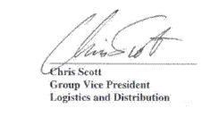

June 26, 2007

To: Our Valued Suppliers

Subject: ***PALLET STANDARDS***

In our continued effort to insure the integrity of quality products and prevent damaged goods from reaching our stores, Winn-Dixie would like to restate our Pallet Policy on products shipped to our Distribution Centers.

Purchase orders must be shipped on white hardwood good GMA Grade “A” pallets. We also continue to encourage your participation with either CHEP, PECO or iGPS as a preferable alternative. (Pallet specifications attached.)

Any damaged pallets received into our Distribution Centers must be re-stacked on good pallets prior to completion of the delivery. A charge of $25.00 per bad pallet will be deducted from purchase order invoice at time of payment.

We appreciate your ongoing efforts in partnering with Winn-Dixie to increase the efficiency and integrity of products shipped in the supply chain.

# Pallet – Configuration & Standards

Size: 40” width x 48” length

Type: GMA standard hardwood pallets or 4-way entry rental pallets

Material: Group III and/or Group IV hardwood

Grade:

* Grade “A” quality, four-way, flush, non-reversible pallet
* Seven boards on top, five boards on bottom, and three stringers
* Should not contain broken or missing stringers or boards
* No double stringers or patched boards
* Nails should not protrude from any pallet surface

A product that is placed on a pallet is not to hang over the edge. This will reduce damage during the normal shipping, storage, and handling process. Shipping labels are to be placed facing out. Each pallet must be shrink-wrapped or banded to ensure that product is received intact.

## Pallet – Penalties

All pallets received by Winn-Dixie are to meet the above standards. All pallets that do not meet GMA Grade “A” standards are subject to manufacturer penalty and/or rejection. Specific penalties will be managed on an individual manufacturer basis, dependent on compliance with these pallet quality standards.

## Pallet – Exchange Program

Winn-Dixie no longer participates in a pallet exchange program.

Thank you for your adherence to this policy!

Sincerely,



**WINN-DIXIE GMA STANDARD FOR GRADE “A” WHITEWOOD PALLETS**

**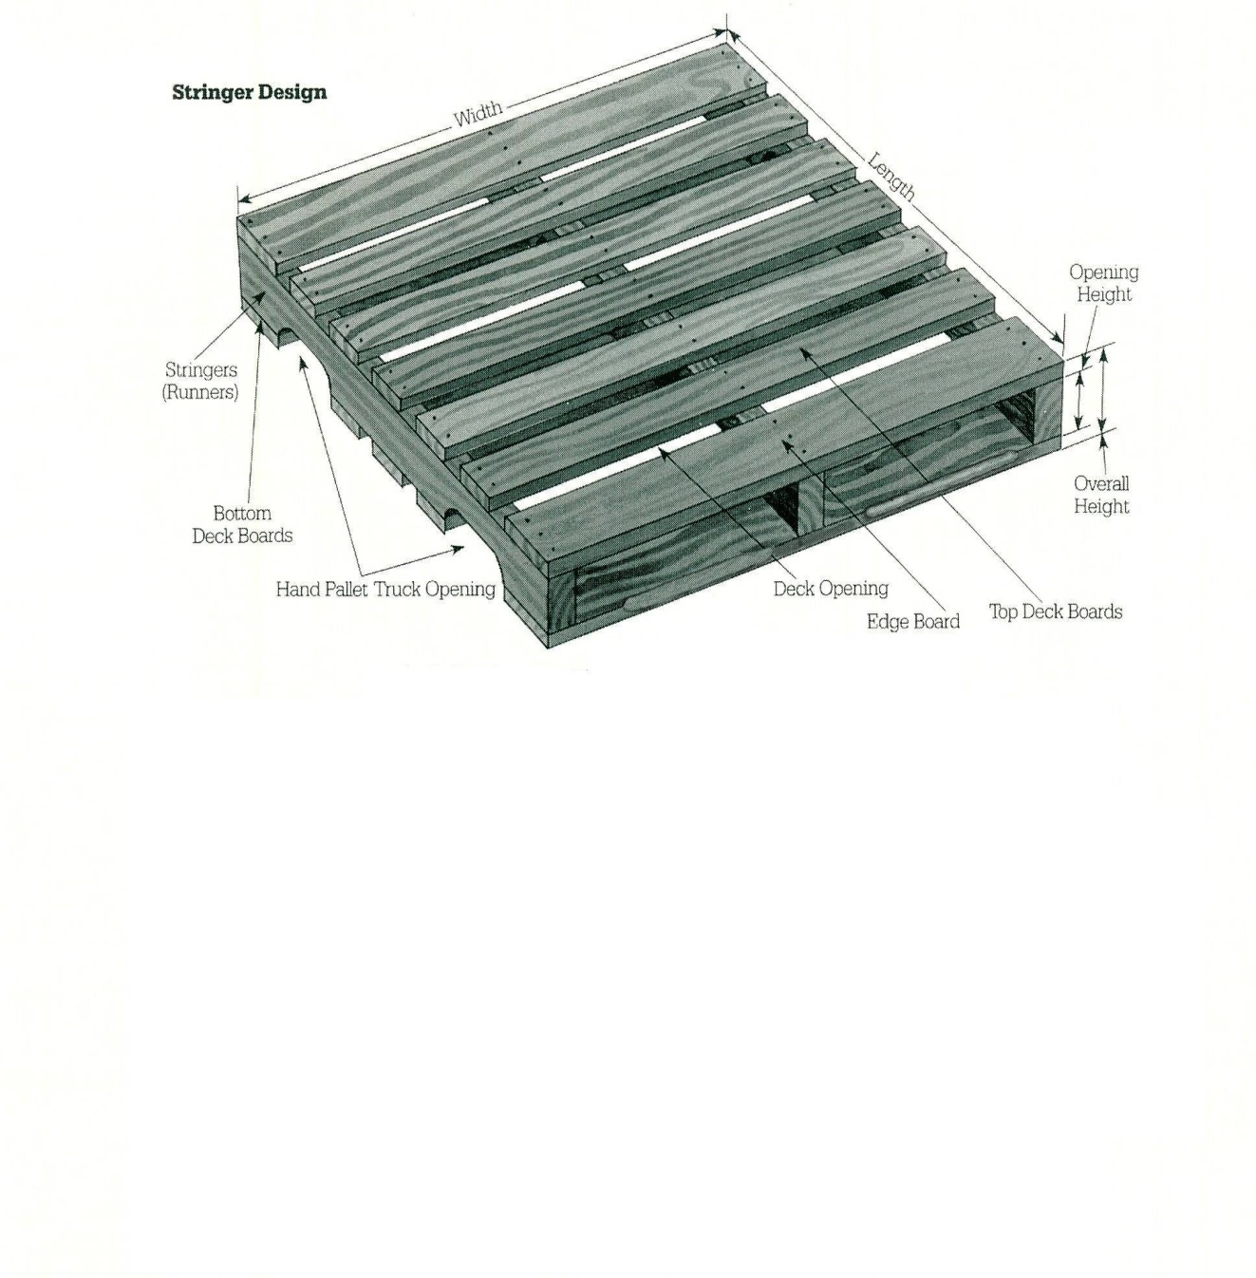**

# Description:

1. 3 pieces 1-3/8” x 3-1/2” x 48”
2. 2 pieces 5/8” x 5-1/2” x 40”
3. 5 pieces 5/8” x 3-1/2” x 40
4. 2 pieces 5/8” x 5-1/2” x 40”
5. 3 pieces 5/8” x 3-1/2 x 40”

Tolerance on 1-3/8” stringer width = 1/8”

Tolerance on 5/8” deck board thickness = 1/16”

**Winn-Dixie Specifications of an Acceptable Pallet:**

1. Winn-Dixie GMA-type Grade “A” 4-way Pallet, 48 x 40 (WINN-DIXIE stock# 00)

GMA type, 48 x 40, stringer-style, wood pallet constructed of all hardwoods, notched stringers creating a partial 4-way entry 5-1/2”" wide lead boards on top and bottom. Lead boards are flush with end of stringer (1/2 finger space allowed, but no chip back or missing deck board space created by damage). Standard GMA 7-top board and 5-bottom board configuration. Interior deck boards 3-1/2" wide (all deck board widths are nominal). Minimum deck board thickness is 5/8" with 1/16” tolerance. Maximum 3.5" space between deck boards. Pallet shall have good color. Stringers have no block or companion board repairs, no corrugate repairs, and no plate repairs. No painted stringers. No Pine boards.

# **Case Integrity Standard**

**Purpose:** To ensure that Winn-Dixie Logistics receives and ships all inventory with each case at a saleable standard for any retail location and to assist in managing and tracking damaged inventory.

**Outline:** I) **Case Integrity Standard**

II) **Examples that fail to meet the “CIS”**

#### Case Integrity Standard

### Shelf Quality Condition

All product put on a retail shelf should be without flaw. Our customers expect each selection to contain all that they are paying for and be packed without damage.

### Shipping Unit Must Be Complete

### The case must contain all the units of sale and they must be in shelf Quality condition

### C. Packaging

### The packaging must be close to original condition and without flaws that jeopardize the Shelf Quality Condition.

#### Examples that fail to meet the “Case Integrity Standard” (see pictures where noted)

1. **Any unit of ship that is missing internal units**
2. **Any case that the packaging has been jeopardized**
3. Temperature specs are no longer met.
4. Code date is out of spec for receiving or shipping
5. Out of their original shape or form.
6. Crushed
7. Leaking
8. Rust
9. Crease
10. Fork stab
11. Opened

# **Inbound Receiving**

**Purpose:** To control receiving with level scheduling, efficient unloading, thorough checking of items for quality and accuracy, pallet inspection and proper documentation of all paperwork.

**Outline:** I) **Prior to Receiving**

II) **Inventory Receiving Standards**

III) **Documentation and Handling Delivery Exceptions**

IV) **Closing Out Receiving Process**

#### Prior to Receiving

### Carrier making appointment

All appointments are made with our receiving clerk with a minimum of 24 hr notice. Otherwise, they will be worked in if possible. If the appointment requested is on a day when the receiving schedule is at capacity, an appointment will be granted a day earlier first or the first day capacity is available. If a carrier shows up after their appointment or needs to be unloaded outside of the normal receiving hours, they will be subject to an unloading fee. When the carrier makes an appointment they are assigned a date and day of arrival, a time for unloading, and a dock door number.

1. **Carrier arrives at distribution center**

Once the carrier arrives, he must check in with security and wait at an assigned place. The seal is not broken until the carrier is instructed to back to the appropriate door and matched with the paperwork by a Winn-Dixie representative.

### The unloading process

The carrier will determine the method of unloading (carrier vs. unloading service). If the carrier chooses to unload, he must supply proof of Powered Industrial Truck certification and proof of $2 million insurance to use Winn-Dixie equipment. There are a few unloading exceptions with vendors that Winn-Dixie has made to handle the unloading process and those exceptions will be listed in the receiving office and on the “W” drive. All pallets are placed at a predetermined location on the dock.

### Inspection

**Winn-Dixie inspectors will examine trailers and product for infestation, code date** **compliance and temperature abuse prior to checking in the inventory.**

***II)* Inventory Receiving Standards**

**All loads must meet the following criteria for acceptance:**

Within temperature and code date requirements for acceptance. *(See attached requirements)*

1. The trailer must be infestation free and not shifted or falling over.
2. The pallet must meet the Grade “A” standard pallet or be on the CHEP or PECO / IGPS program. If not it will be required to be placed on one. If this is not met a fee could be charged to the carrier. (*See the attached Winn-Dixie* ***pallet specification****)*
3. The items on the pallets must be well stacked, without damage, and overhang to GMA guidelines and meet the predetermined Ti x HI specifications set By Winn-Dixie Logistics.
4. ONLY the items and the quantity of each item that matches the Purchase Order will be received. All other items and excess of each item will be **REJECTED**.
5. The items will be inspected for damage or abuse. Cases not meeting Winn-Dixie **“Case Integrity Standard section I”** will be rejected and returned.

#### Documentation and Handling Delivery Exceptions

### Delivered Loads:

### The carrier’s paperwork

Once all checks are complete, the Receiver signs, dates and notes all exceptions OS &D (over, short and damage) claims listed on the carrier’s paperwork.

* **ALL EXCEPTIONS must be noted on the paperwork from the carrier.**

1. **Back-haul or 3rd Party Carrier:**
   * **Handling Delivery exceptions – Shortages**

**Follow the steps listed in the “The carrier’s paperwork”**

## Handling Delivery Exceptions – Over and/or Damage

## External carrier /vendor or Winn-Dixie Backhaul with WD driver checking on the dock at the time of load:

## Mark paperwork “Refused and returned with the case amount received and the case amount rejected”, WD will complete the exception form and return the product on the truck or in the case of the backhaul… will leave with the vendor.

* + 1. **Winn-Dixie 3rd party contracted carrier or Winn-Dixie Backhaul with Driver not allowed to check on dock,** 
       - **Driver should mark paperwork “Shipper load and count” or Rail car or container or LTL Deliveries.**

## Winn-Dixie associate will mark paperwork with the number of good cases received, number of cases “ON LOAD BUT NOT RECEIVED IN SYSTEM”. These cases will be stored in the Damage Processing Area until disposition is given. If Disposition hasn’t been given in 48 hours then the Department Superintendent will contact the Inbound Logistics group for assistance.

## 

#### Closing out Receiving Process

### The Load

The Receiver verifies all Inventory Receiving Standards are met.

### The carrier’s paperwork

Once all of the checks are complete, the Receiver signs, dates and notes all exceptions on the carrier’s paperwork. He keeps a copy and turns in to the Receiving office. This paperwork is keyed into the system and the if needed a Delivery Exception Form is completed.

### Releasing the Carrier

The Receiver checks the back of the trailer, closes the dock door and signs the gate pass.

|  |  |  |  |
| --- | --- | --- | --- |
| **WINN-DIXIE RECEIVING** | | | |
| Temperature Specifications | | | |
|  | (all temperatures are in Fahrenheit) | |  |
|  |  |  |  |
| ***Product Category*** | ***Specification*** | ***Question \**** | ***Reject*** |
| Ice Cream | -20 to -10 | -9 to 0 | above 0 |
| Frozen Food | -10 to 0 | 1 to 15 | above 15 |
| Meat | 28 to 32 | 33 to 38 | above 39 |
| Fresh Seafood | 28 to 32 | 33 to 38 | above 39 |
| Milk | 32 to 35 | 36 to 39 | above 39 |
| Dairy Products | 32 to 35 | 36 to 39 | above 39 |
| Produce (wet box) | 32 to 35 | 36 to 40 | above 40 |
| Eggs | 35 to 40 | 41 to 45 | above 45 |
| *(note: with eggs, it is the temperature of the storage environment that is measured, NOT the internal temperature of the egg.)* | | | |
| Live Seafood | 38 to 45 | 46 to 50 | above 50 |

Guideline

Case markings and Packaging Requirements

Purpose

To ensure uniformity of case markings and adequacy of the cases received in the facilities for Winn-Dixie

Definitions

Case Packaging enclosing the product

Tray Packaging base with suitable wrapping and protection of the products that stand above the base.

Packaging Principles

The packaging must be suitable for the product. The packaging must be suitable for manual selection as well as automatic selection. The following requirements must be adhered to:

* The base must be suitable for placing on a pallet, or a slip sheet. The base must be suitable for use in case flow racks with only two lines of wheels.
* The packing must be suitable for vertical stacking of the product to a height of 60” or the actual height of stacking, whichever is the higher.
* The stability of the pallet must not be made by adhesive between one case to another as this inhibits the selection by manual means
* Where trays are utilized, the wrap above the tray must be made to not only secure the product into the tray, but also to present a flat and level surface on the top so that the same or other products can be stacked on the entire top surface of this product.

Markings

The following represents the best practice that is required for all case markings. The following represents the requirements for all product entering the facilities:

* A machine readable bar code representing the product code
* A human readable product code
* Product name and description
* Production date, expiration date or best-use-by date
* Weight or type or quantity
* Manufacturers or distributors information
* Any regulatory information.

The locations of these various groups of information is as shown in the diagrams below:

**Case**

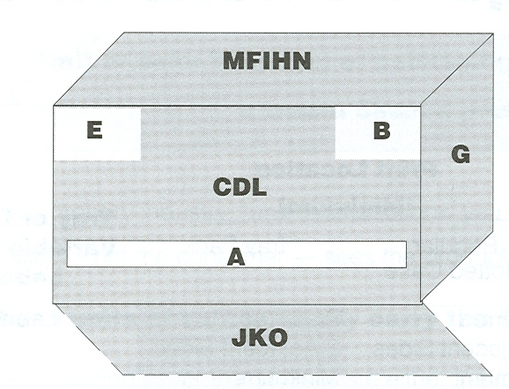

Base of case

**Tray**

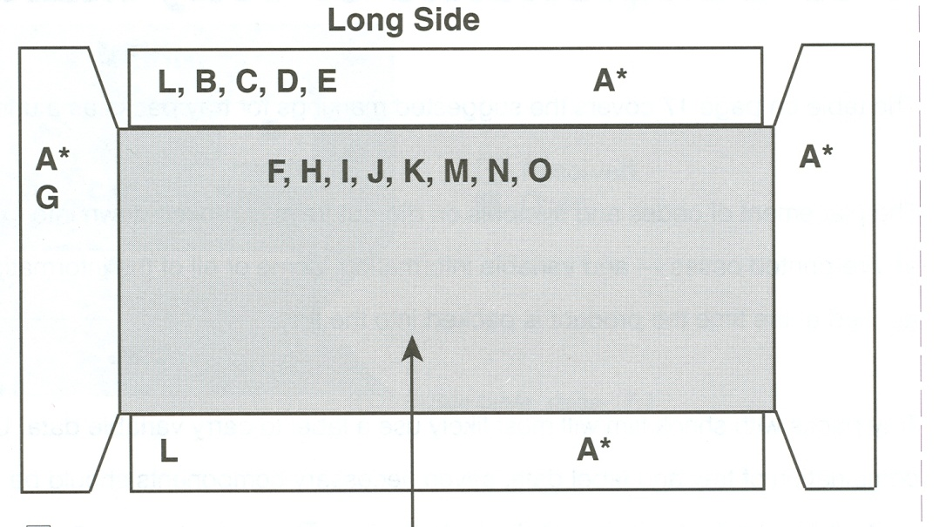

Base of tray

**Case and Tray Marking Components**

**Print Location**

**(Minimum)**

**Panel Required/** Regular **Tray or Case**

**Component** **Reference Optional** Slotted Case Tray Pack **Variable Data**

**Bar Code Symbol** A Required Preferred: Preferred: Label

2 Adjacent Sides 2 Adjacent Sides

Minimum: Minimum:

1 Long Side 1 Long Side

**Product Code** B Required Preferred: Preferred: Label

(Human Readable) 2 Adjacent Sides 2 Adjacent Sides

Minimum: Minimum:1 Long Side 1 Long Side

**Product Name** C Required 1 Side (Long) 1Side(Long) Label

(Flavor, etc.)

**Product Description** C Required 1 Side (Long) 1Side(Long) Label

(Flavor, etc.)

**Product Date/**  D Required 1 Side (Long) 1 Side (Long) Label or Case

**Best Use/Lot Code/**

**Expiration Date**

**Item Configuration/** E Required 1 Side (Long) 1 Side Long Label or Case

**Net Weight/ Qty/**

**Container Type**

**Signature Line** F Required Top Bottom Case/Tray

(Sold By)

**Regulatory** G Required 1 Side (Short) 1 Side (Short) Case/Tray

(USDA, etc.)

**Handling Instructions** H Optional Top Bottom Case/Tray

**Storage**

(This Side Up, etc,)

**Pallet Pattern** I Optional Top Bottom Case/Tray

**Re-Cycle Symbol** J Optional Bottom Bottom Case/Tray

**Packaging Material** K Optional Bottom Bottom Case/Tray

**Re-Order Number**

**Logo** L Optional 1 Side (Long) 1 Side (Long) Case/Tray

**Opening/Assembly** M Optional Top Bottom Case/Tray

**Instructions**

**Disclaimer** N Optional Top Bottom Case/Tray

**Box Makers** O Required Bottom Case/Tray

**Certificate**

.

Barcode Sizing and Placement

The barcode is a critical piece of information and must adhere to the UCC / EAN codes at all times.

The placement of the barcode will be as follows, with the barcode complying with the requirement for the size as shown:

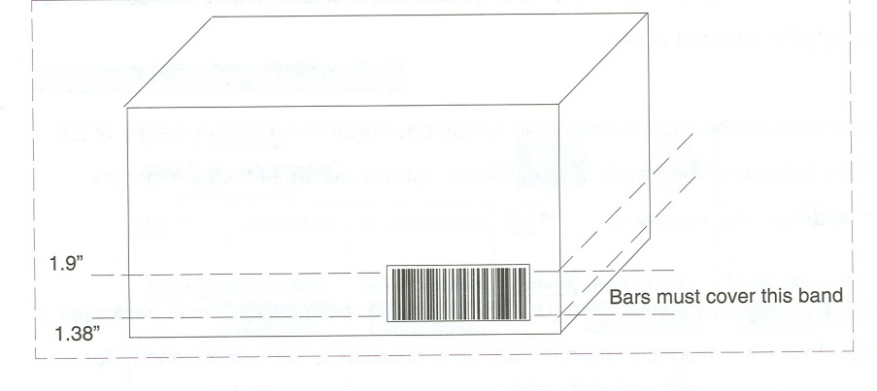

The placement of the barcode is as per the Markings section.

**MINIMUM FRESHNESS DAYS**

**Effective March 31, 2003** Winn-Dixie Stores, Inc. will establish the following minimum freshness days guidelines for all open-code and/or Julian calendar code dated products as follows:

* All dated products shipped to Winn-Dixie distribution centers will be expected to meet the minimum freshness days that we have established for each SKU based on the manufactured shelf life.
* These guidelines are designed to ensure that Winn-Dixie receives all dated products with a fair and acceptable shelf life.
* Failure by any manufacturer to meet these guidelines and/or ship close-dated products to our distribution centers will result in the rejection of any and all SKU’s falling below our minimum freshness days’ guidelines.
* All new products sold to Winn-Dixie Stores in the future should meet these guidelines.
* When a manufacturer introduces an entirely new product line, it will be the manufacturer’s responsibility to provide the manufactured days at production. Minimum freshness days will be calculated by Winn-Dixie based on that date. Failure to provide this information will result in the refusal and rejection of any new item at the point of receiving.
* There will be exceptions to current guidelines for any new products containing fresh ingredients and/or a product formula that creates a shorter or lesser minimum freshness days than current guidelines. It will be the responsibility of the manufacturer and/or sales representative to communicate these exceptions to the Supply Chain Managers’ Office for Food. A determination and final decision will be made as to accuracy of all requests for an exception to our current guidelines.
* Each manufacturer and/or manufacturer sales representative must ensure that all promoted and/or advertised product sold to Winn-Dixie has not aged in your distribution center and/or mixing center beyond our minimum freshness days guidelines. In the event this occurs, it is expected that the Category Director and/or the Category Manager would be contacted prior to shipping any promotional purchase order(s) to a Winn-Dixie distribution center.

Please ensure that each Supply Chain Manager and/or Logistics Manager in each of your company’s operating divisions are forwarded a copy of this policy.

For additional information please contact Joel Cambron, at [joelcambron@Winn-Dixie.com](mailto:amyhowland@winn-dixie.com) in the event you have additional questions and/or concerns.



**THIRD PARTY UNLOADING CHARGE RATES**

**Pricing at the Baldwin, Orlando, Miami, Montgomery, and Hammond Locations**

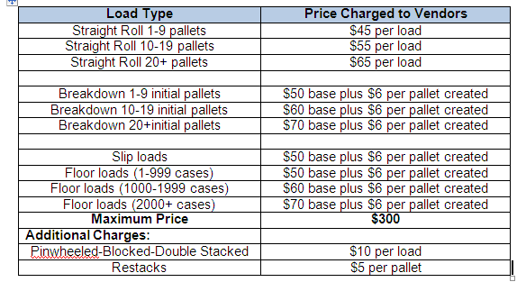

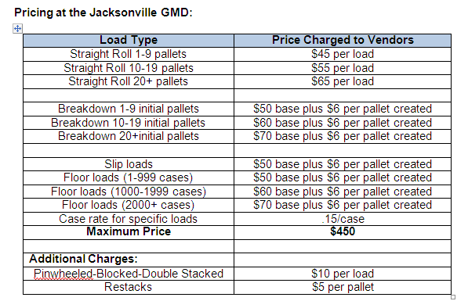

These Charge Rates are provided as a guide and are subject to change.



March 01, 2009

To: Our Valued Suppliers

Subject: **Product Recall/Removal Processing Fees**

With the increased supply chain costs and the increasing recalls and withdrawals occurrences, we find it necessary to recover the labor and disposal costs of removing these items from our stores and distribution centers.

The following product removal processing fees apply to the withdrawal, removal, or recall of any product from Winn Dixie Stores and distribution centers that is the result of quality concerns, labeling errors, possible contamination or threat of illness, packaging errors, regulatory requirements, adulteration, purported infringement or other legal claim or concern, or any other reason that is the result of a supplier-controlled product issue. These fees will not apply if the product removal is the result of Winn Dixie’s improper handling of the item.

* $20 minimum per store per item number/UPC withdrawn — every item (each item number or UPC) removed from sale will be subject to this assessment to offset store labor and associated administrative expenses incurred as a result of the removal. An additional assessment may apply for increased costs in unusual situations.

Item disposal fees — Winn Dixie prefers that all non-hazardous/non-chemical items be returned to the Supplier for proper management or disposal. Any item disposed of at store level would be subject to the following additional minimum charges:

* $20 Minimum per store for non-hazardous/non-chemical items disposed of at store level in dumpsters or company owned reclamation centers.
* $100 Minimum charge per store for any item that must be disposed of through our hazardous/chemical waste management process. Depending upon the volume and weight of the item(s), this charge may vary and alternative methods of managing proper disposal may be required.

Additional charges for any unusual processing or burdens may be assessed.

* Suppliers are responsible for all shipping costs.
* Shipments to and consolidations by the Reclamation Center will include a handling fee as provided for in the *Winn Dixie Stores, Inc Corporate Reclamation Agreement.*

Items that are subject to a “Pull and Hold” will not incur any fees unless and until the “Pull and Hold” results in an actual removal of the item.

Additional costs related to any special handling requirement or burdens will be addressed as circumstances warrant. To be clear, the fees as provided are the minimum fees, and do not limit Winn Dixie’s right to recover any costs (whether at store, DC or Return Center) of a product removal greater than the guideline amounts.

The following are examples of how Winn Dixie will assess Product Removal Processing Fees.

Example 1— A supplier has two items in 523 stores that are removed from sale and returned to the supplier for management and disposal.

Example 2— Same scenario as first example, except the Supplier opts to have the non-hazardous items disposed of at the stores.

1. Processing Fee only

* Fee per item (UPC)$20
* Number of Stores 523
* Number of items withdrawn 2
* Total processing fee $20,920

2. Processing fee plus non-hazardous item disposal

* Processing fee (see example 1)$20,920
* Non-hazardous disposal fee / per store $20
* Number of stores 523
* Disposal fee sub-total $20,920
* Total withdrawal fee charged to supplier $41,840

Note that, in any case, the Supplier will be obligated to bear any shipping costs and any Return Center handling fees.

This has become standard practice for retailers throughout the industry to recover additional supply chain costs for FDA/USDA recalls or product withdrawals. Should you have any question regarding this or any other reverse logistics program please direct them to Gary Regina, Supply Chain Manager [garyregina@winn-dixie.com](mailto:garyregina@winn-dixie.com) or 904-370-6351.

**This fee schedule will be effective (April 01, 2009)**

We look forward to your cooperation as we continue to service our mutual customers and grow our business together.

Sincerely,

The Winn-Dixie Routing Guide and Supplier Compliance Instructions are meant to serve as a comprehensive tool establishing how to interface with your company. The information contained in this document reflects your commitment to reduce the cycle time in transporting your product through the supply chain. This requires a focus on controlling unnecessary freight and labor expenses. The instructions contained in this document should be clear and should be given careful consideration as to standard business practices used to transport materials. Winn-Dixie will not pay any accessorial charges on prepaid shipments. Any charges such as notification, storage, re-consignment, inside delivery, sorting/segregating, etc., will be the sole financial responsibility of the vendor. Compliance with these policies and procedures will ensure a healthy and profitable relationship between your company and Winn-Dixie.